**Project Design Phase-I**

**Solution Architecture**

| Date | 19 September 2022 |
| --- | --- |
| Team ID | PNT2022TMIDxxxxxx |
| Project Name | Gas Leakage Monitoring and Alerting System |
| Maximum Marks | 4 Marks |

**Solution Architecture:**

* Gas sensor is used to find if there is any gas leakage in the surrounding and if any toxic gas found in the surrounding then it intimates the IOT device such as node mcu or raspberry pi
* The IOT device is connected to wifi ,server,alarm and led once the gas sensor intimates the IOT device the it triggers the alarm and led and send the data to the server
* The server collects the data and stores the data in a database and the web page gets the data from the database and updates
* IFTTT is used to collect the data from the database and alert the main person using sms and the email system

**Example - Solution Architecture Diagram:** 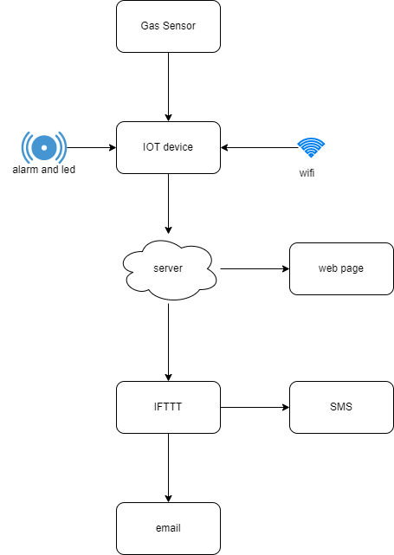

*Figure 1: Architecture and data flow of the voice patient diary sample application*